BRDF

What:

Why:

How:

BRDF Input？

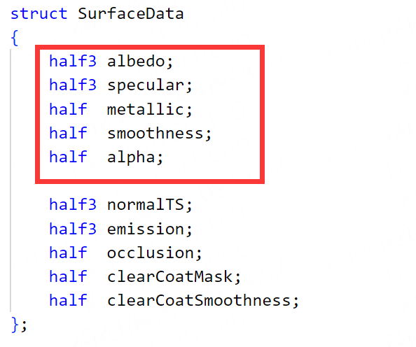

BRDF Output？

